Hokotehi Moriori Trust

2011 Congress Proceedings
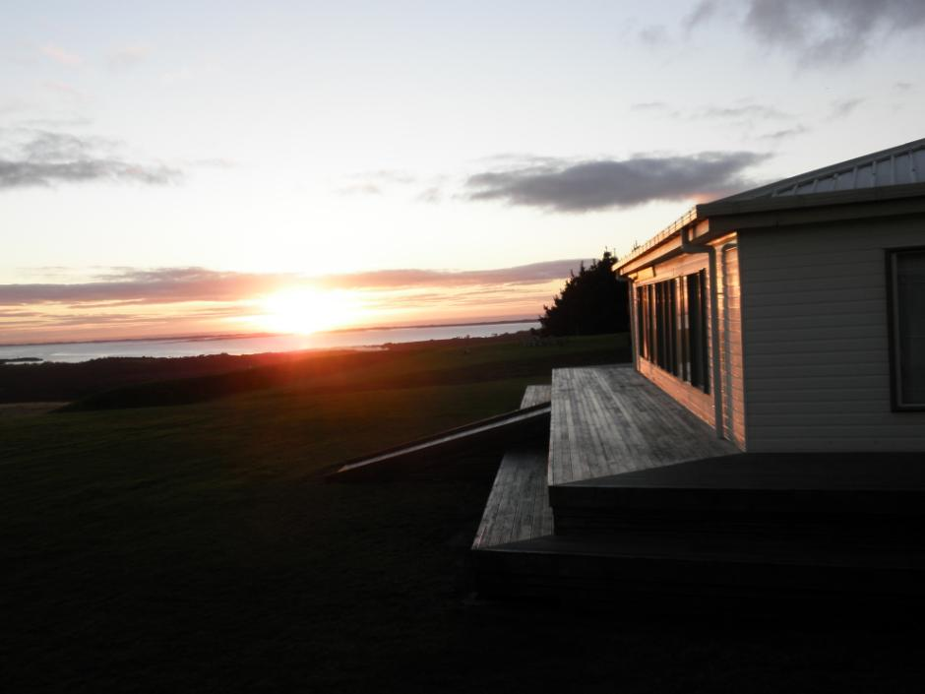
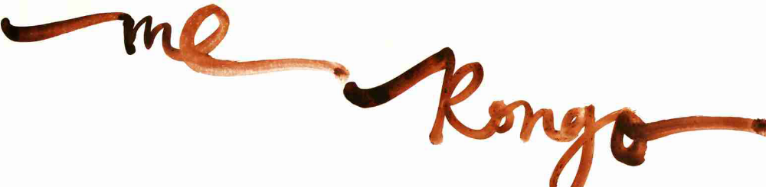
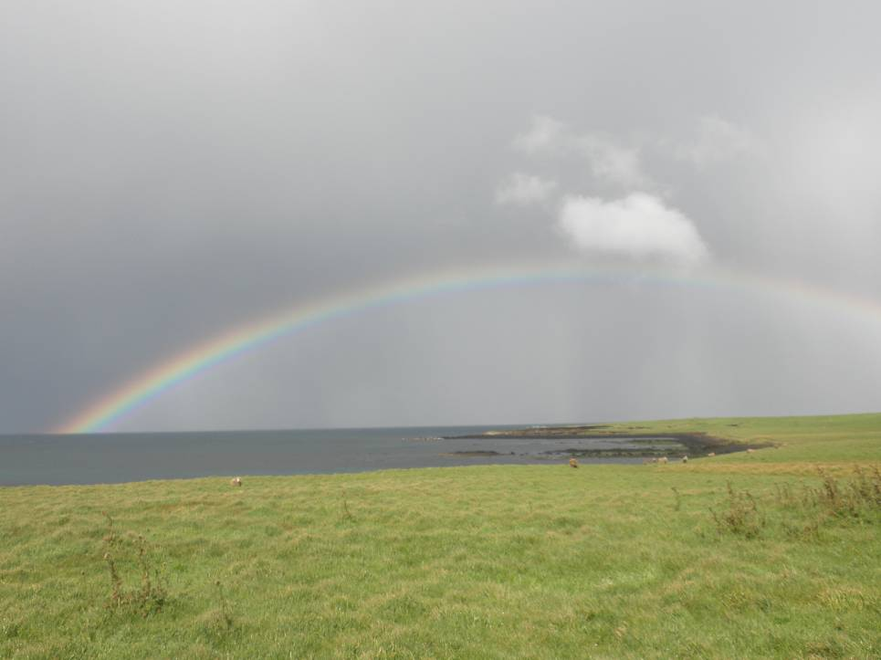

Ka Pou a Rangitokona
Tongia tenga rehu Tawake moetahuna
Koi tenga mokopu o Rongomaiwhenua o Rongomaitere
Koi tama wainuku
Koi tama waiorangi
Koi tama ruruhau o Pāpātuanuku

Tahia te ihinga mai o te Ra
Tahia koi tama Rehua-Tane
Moe tahi koe i runga
Tahia te nui Tahia te roa
Werohia te ata

The ritual Moriori karakii (prayer) above is describes the separation of Pāpātuanuku and Ranginui and the creation of light and knowledge. It is carved on the post in the centre of Kōpinga marae as a dedication to the memory of Moriori ancestors and their enduring legacy of peace.
CONTENTS

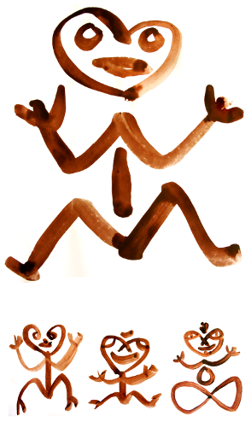
DEDICATION
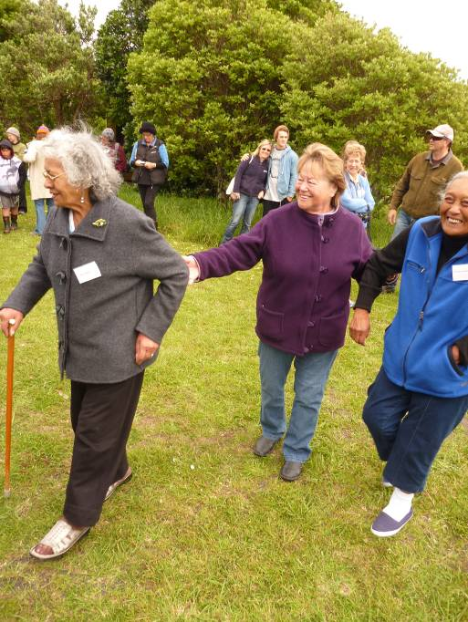
T o the memory of those who we fare-welled during the lead up to and time of the Congress, especially to our beloved Ahenata Clarkson (Auntie May) who’s tangi became part of our gathering. Moe mai kotou; moe mai. Ka nui te mihi aroha ki ngā hūnau pani. Iarohu, me rongo

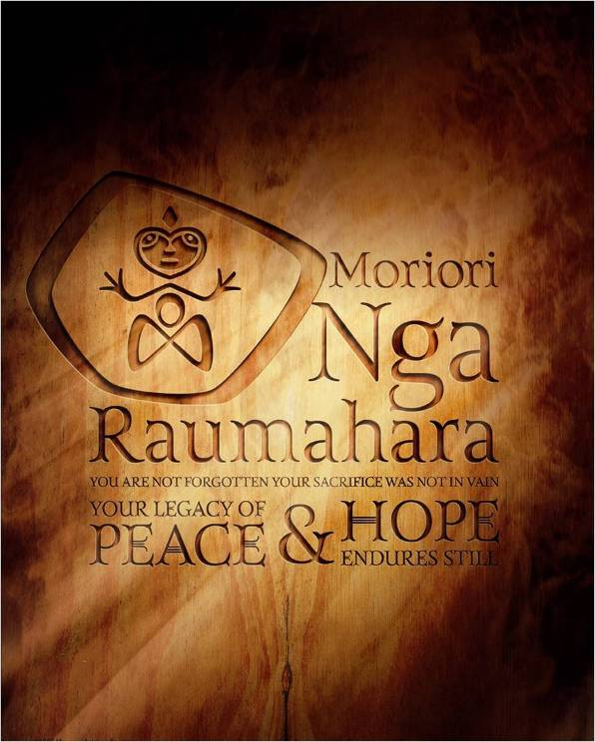
ME RONGO 2011
Hokomenetai, me rongo. In a spirit of unity and peace it was a pleasure to welcome you to the first “Peace, Sustainability and Respect for the Sacred” Congress. In a sense, the Congress has been an event that has been part of the cultural identity of these islands for hundreds of years. A commitment to establishing and holding on to a covenant of peace and conflict resolution has been in place on Rēkohu for over 500 years – the world’s oldest known consistent peace tradition.
Moriori regularly held gatherings to affirm the covenant, particularly in response to crises. This Congress only differs in that we gathered from around the globe.

Background to Me Rongo
In 2009 Hokotehi held the blessing for the World March for Peace and Non-Violence and then attended the close of the march in Punta de Vacas, Argentina three months later. Last year, Hokotehi facilitated a Congress session on Peace, Sustainability and Respect at the 12th International Society of Ethnobiologists Congress in Tofino, Canada where we were joined by presenters from the Hopi Nation and Kanaka Maoli from Hawai’i. The Tofino gathering was conceived as a stepping stone in the lead up to the Me Rongo Congress planned for November 2011. The Tofino gathering was held in an indigenous centre and named Hishuk-ish tsa’walk after a Tla-o-qui-aht expression meaning “everything is one”.
The session (entitled “Peace, Sustainability and Respect for the Sacred”) brought together elders and other experts from around the world who have traditions in peace keeping/making as an integral part of their philosophy. It focussed on the importance of the preservation and transmission of inter-generational knowledge of "living in country" as the Aboriginal peoples of Australia say, and the maintenance and promotion of retention of the local language(s) and cultural practices of the communities that sustain this knowledge. At its heart was an understanding of the importance of the sacred/spiritual/wairua traditions – as an expression of the thread that binds people together with their natural worlds, and which provides the basis for living in a mutually respectful and mutually enhancing relationship of humans, plants and animals.

In addition to providing a collective forum for learning about peace traditions and the importance of being able to practice cultural continuity, the session examined ways in which the modern world may come to a better understanding of how this sacred knowledge or knowledge of the sacred is critical to humankind (re)learning how to live "in connection with" rather than increasingly "disconnected from" our planet and planetary systems.

Me Rongo aimed to build on these special events and become a regular learning experience (every second year) in the lead up to the creation of an international Peace Education Centre on the island.

Me Rongo is a Moriori term meaning “in peace”. It is used as both a salutation and affirmation. The word “rongo” also embodies other vital ingredients for peaceful living, as rongo means “to listen”. Me Rongo implies that in order to be in peace, one must also listen and listen deeply and respectfully. This listening is not just amongst people but also incorporates a deeper listening to the rhythms and sounds of the living systems of which we are a part.

Me Rongo November 2011

The vision for the Peace Congress was to create a meaningful and lasting practice of mindfulness amongst all who attend. We believe that when you have hope for future generations, peace prevails. The Moriori message of peace is something we are proud of and wish to share with the rest of the world, as a beacon of hope.
In a world of increasing ecological strain and decreasing resilience island communities are often the first to feel the effects. Dependency on imports for sustenance and exports for economic survival can contribute to community fragility. However, there is another way to confront environmental and community problems associated with ecological decline, violence and lack of respect. We believe that island communities can be effective models of transition communities for larger nations to follow. If Rēkohu can achieve this then many other nation states can as well.
ACKNOWLEDGEMENTS
Kia ora kotou. Thank you to all those who attended Me Rongo 2011 for your energy, wisdom, humour and grace. The collective energy generated over the three weeks became and willing remain a lasting treasure for Kōpinga, for Moriori and for Rēkohu.
Thank you for being prepared to so creatively and passionately embrace the kaupapa of peace, sustainability and respect for the sacred. All your teachings ensured that learning will continue on the island without reliance on bringing in tools and materials. You encouraged attendees to think in a way that promotes creative resilience. We saw the ease with which attendees spoke honestly and openly about local environmental and political concerns, and thank you for helping create those ‘ethical spaces’ for safe kōrero.
Thank you for bringing your children and grandchildren to share this experience. They are the elders and leaders of tomorrow. Having them with us and knowing their sounds were part of our own listening was inspirational. Their presence too helped counter the sadness so many of felt in the loss of loved ones and elders during the times of the Congress.
Thank you to those who contributed creative works, intelligence and muscle for the preparation of Me Rongo, especially our Advisory Board, our cooking team lead by Turama O’Connor and Tom Lanauze, the marae and Henga Lodge support team of John and Dorcita Swain, Susan Thorpe, Lorraine Norris, Kelvin Carter, Maui Solomon, James Matenga, Sylvia Eyles, our photographer Justin Maxwell, interviewers Robin Atherton, Jade Lomano and their sons, plus the many volunteers who helped during hokomaurahiri and to set up for workshops and presentations, drive, cook, clean, care for babies and timiriki, and paint banners.
Thank you to all our artists, musicians, teachers, creative spirits and healers who brought an extraordinary energy to the Congress. Creative people and cultures in our communities have the capacity to shine a light on truths and the potential for healing through the arts. This was very evident at Me Rongo 2011. We would also like to again thank you all for your generous gifts to the tūahu at Kōpinga. These beautiful taonga will remain as tangible reminders of this very special occasion.
The Congress would also not have happened without supportive from generous donations and grants. Thank you to Pita Thomas (Waitangi Seafoods Limited) for the delicious kaimoana, NZ Lottery Grants Board Creative Communities Scheme, Peace and Disarmament Trust, Department of Internal Affairs, Chatham Islands Enterprise Trust, Stone Circle Organics, Organic Breadman and Whittaker’s Chocolate.
Finally, thank you all for your commitment to the tohinga Me Rongo during the opening celebrations. The re-dedication of the covenant of peace has added another layer in the Kōpinga korowai.
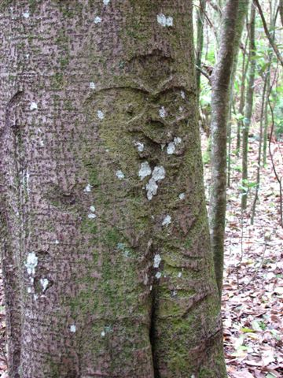

CONGRESS PROCEEDINGS
Congress Workshops
Earth without art is “eh”!
Me Rongo was honoured to have the presence of some internationally respected artists and experts assist with workshops. Joining us were:
Owen Mapp | Bone carving with hand tools | www.art-jewelery.com
Hanne Eriksen | Jewellery | www.art-jewelery.com
Wi Taepa | Clay art, carving
Liz Taepa | Tā: mixed media mark making, painting, calligraphy and printing
James Webster | Taonga Puoro and Karetao | www.tahaa.co.nz
John Lamb | Weaving
Tina Makereti | Voices of Rēkohu writing workshop | http://www.tinamakereti.com
Rick Thorpe | Sustainable Ecology, Waste Management and Transition Communities | www.xtremewaste.org.nz
Liz Stanway | Organic Gardening and Permaculture | www.xtremewaste.org.nz
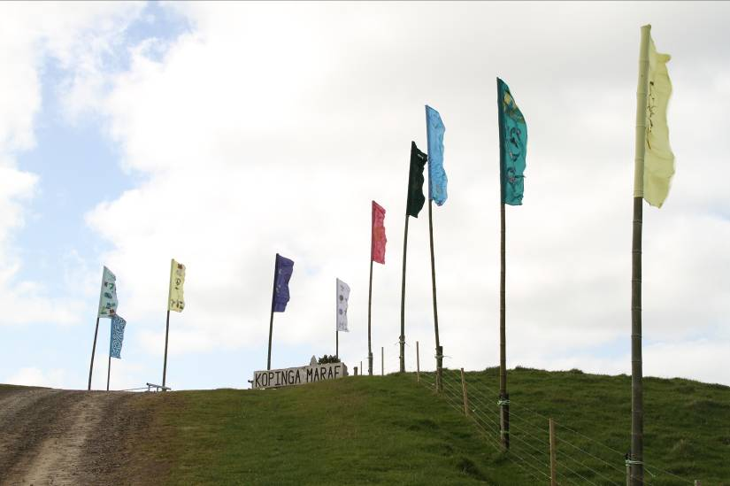

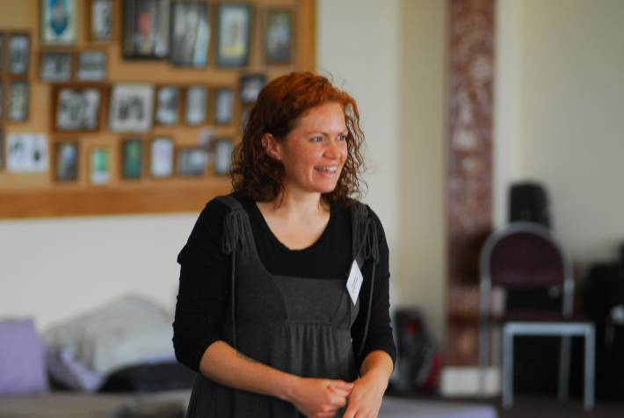
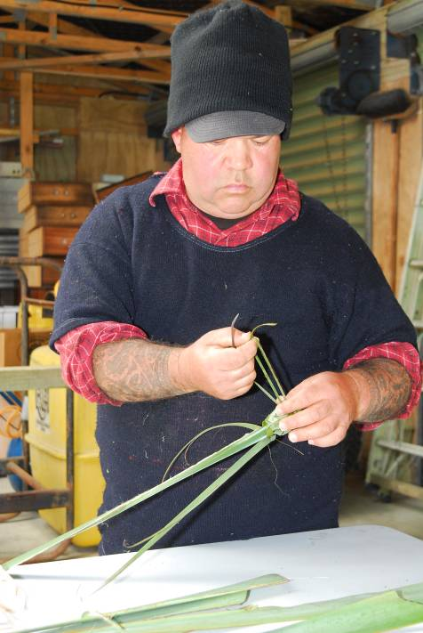
John Lamb

Tina Makereti

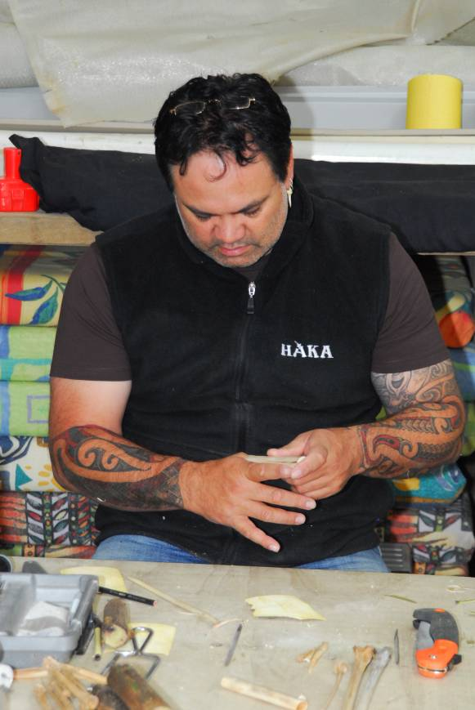
James Webster
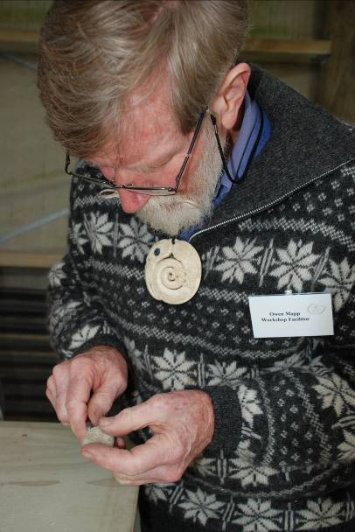
Owen Mapp

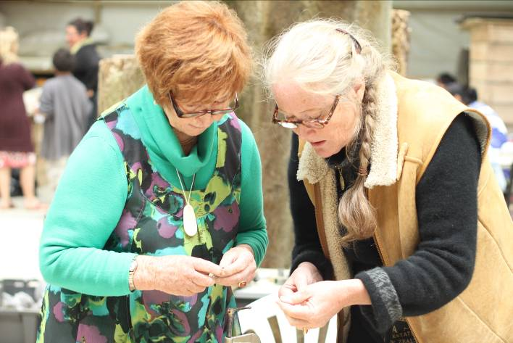
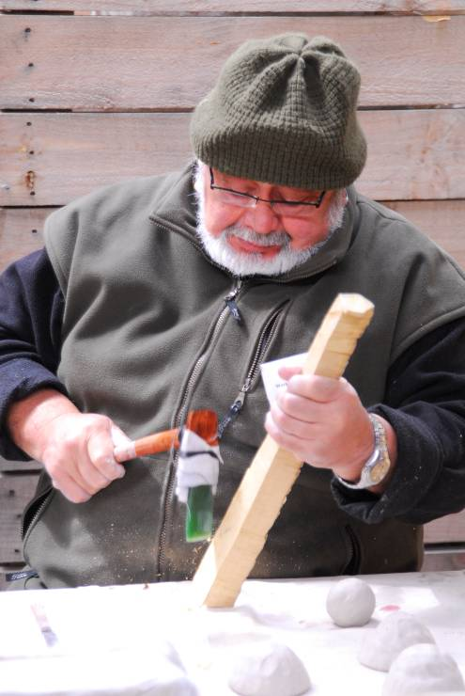
Hanne Eriksen on the right (with Ngaere Annie Bottcher)
Wi Taepa

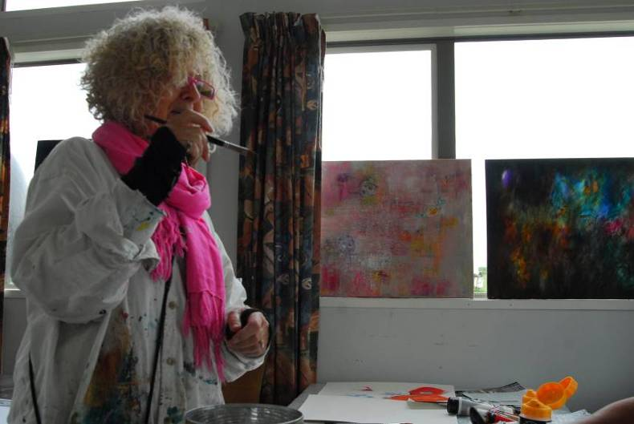
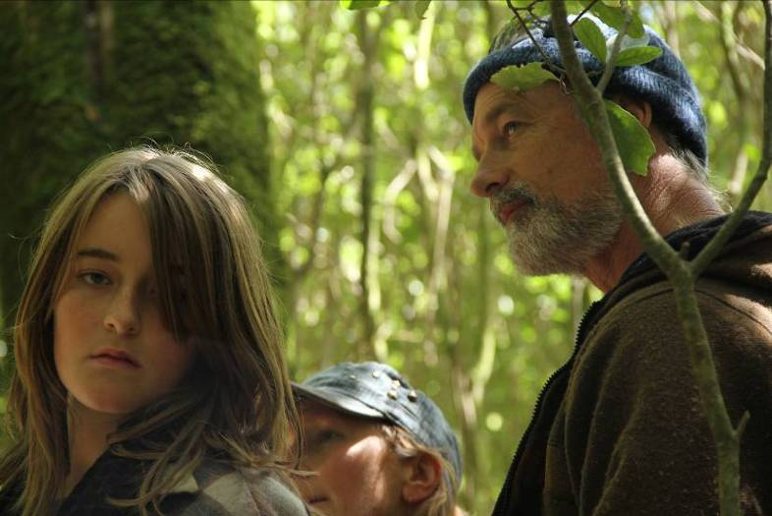
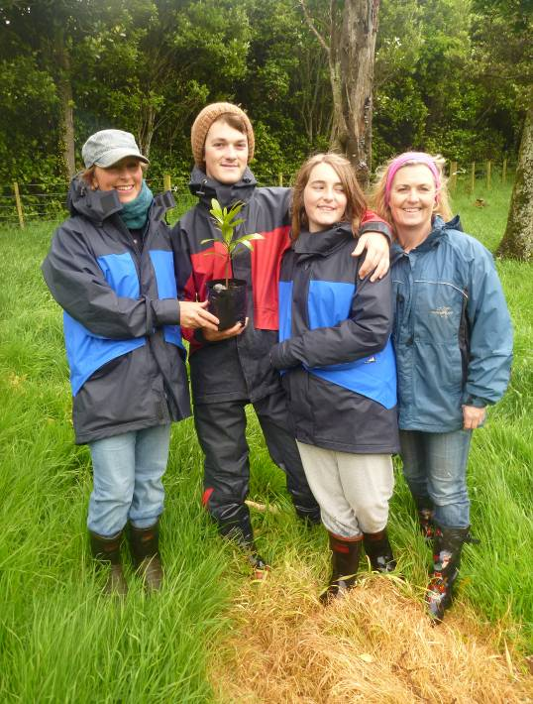
Liz Taepa
Liz Stanway (on the left) and hunau (Zak, Pania, Susan)
Rick Thorpe (on the right) with Pania and Liz (obscured)
FOOTPRINTS OF THE RĀPUNA
Hapupu henga manukau korako
Planting

Opening Ceremony
The Congress opened with karakii and speeches of welcome, which included filmed messages of peace from colleagues from the World March for Peace and Non-Violence, Rafael de la Rubia and Montserrat Prieto and Moana Maniapoto, composer and singer of the beautiful Rongo, Rangikane Ana, which was written for the opening of Kōpinga and became the Congress theme song.
Links to the Congress to these greetings and the opening and closing films are below:
- Opening film: http://dl.dropbox.com/u/49424609/me%20rongo%202011-web.wmv
- Closing Film: http://dl.dropbox.com/u/49424609/me%20rongo%20closing-web.wmv
- World March for Peace and Non-violence film: http://marchamundial.tv/Rekohu/

- Moana’s mihi: http://dl.dropbox.com/u/49424609/Moana%20Maniapoto%20mihi.MOV (please note that she has been recorded sideways, so you will have to do likewise!)

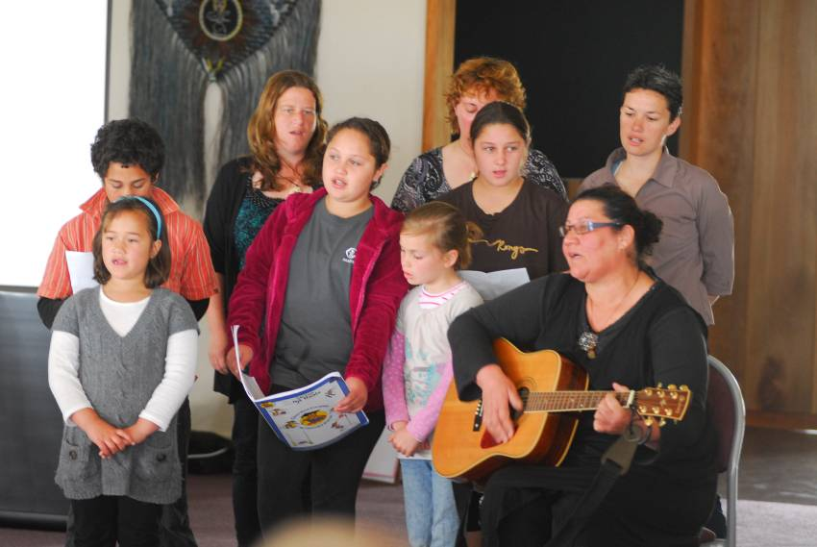
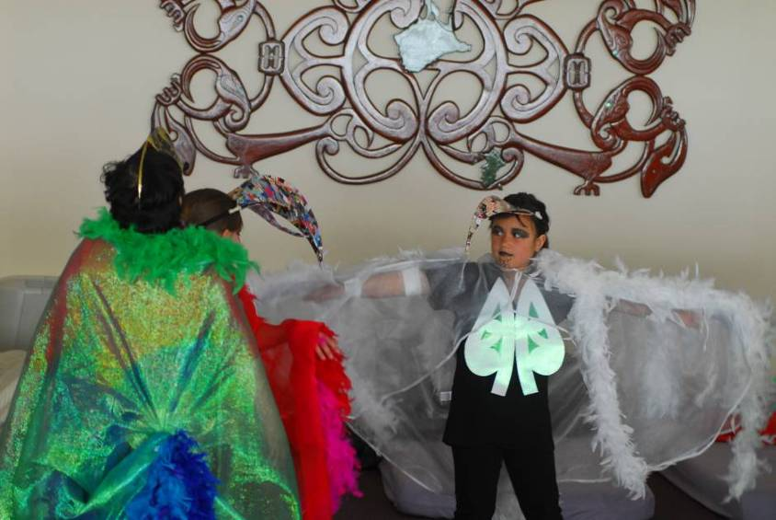
This was followed by the gift of a beautiful rongo composed by Huhana Carter and sung by the students and parents of Kaingaroa School. Their koha was accompanied by beautifully painted banners from the school, which explored notions of peace and sustainability. The ceremony concluded with the re-dedication of the covenant of peace with opening words from Professor David Williams and the reading of Te Tohinga by Jade Lomano and Luke Chamberlain-Solomon, and finally a performance from the kura showing Tane and his manu – all in costumes made from recycled materials.

School rongo

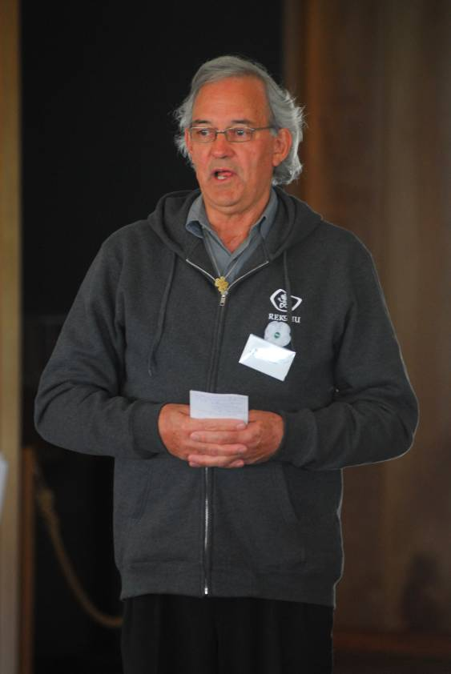
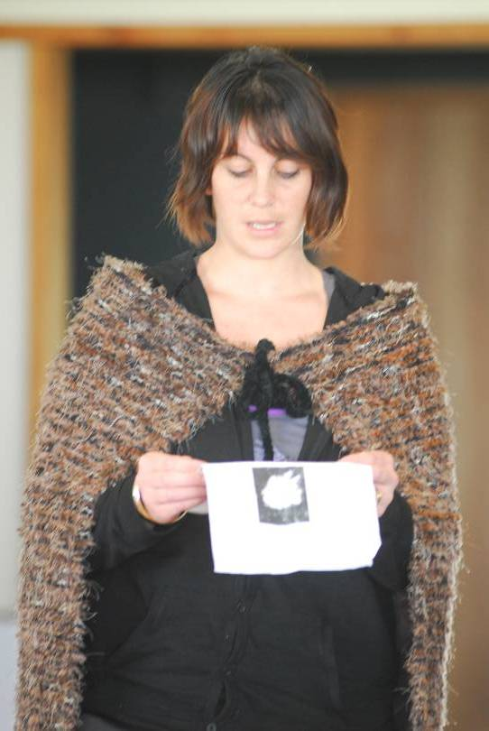
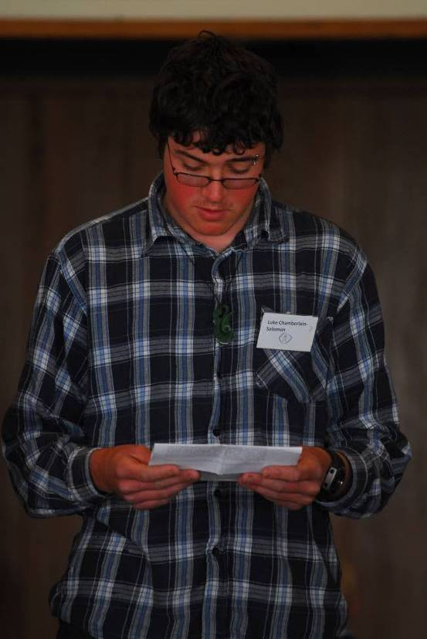
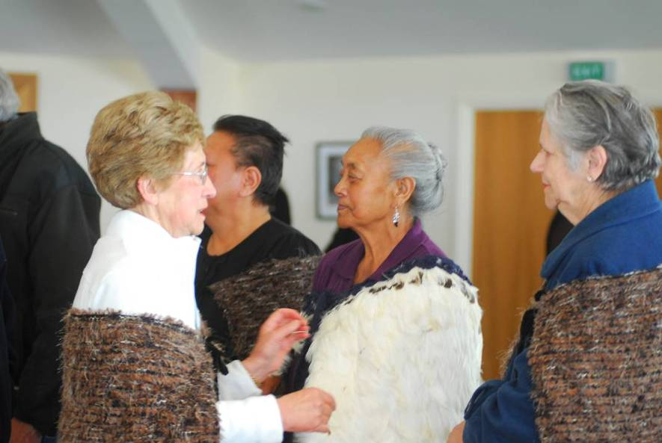
CONGRESS PROCEEDINGS

- Consensus Decision-making - Prof David Williams and Helen NcNeill
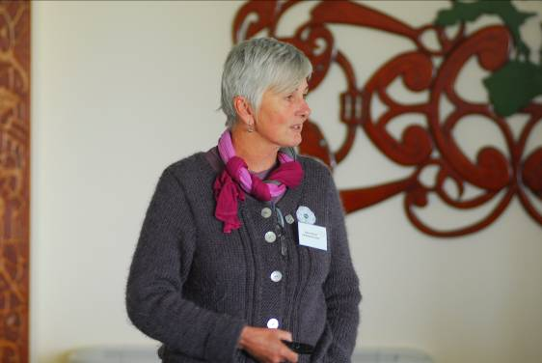
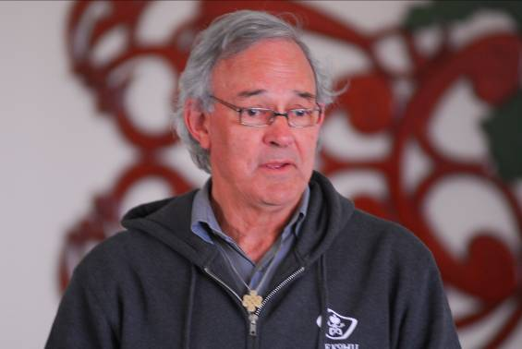
Abstract
What does democracy mean? The majority always 'wins'? What about the minority?
This workshop was about skills and mindsets needed for reaching a consensus in decision-making processes. Consensus decision-making means that all voices can be heard and that the decisions arrived at are generally acceptable for everyone involved.
David and Helen described a procedure using coloured cards for facilitating discussions and decision-making. This has been adopted in co-housing communities in a number of countries and is used for consensus decision-making at Earthsong Eco-Neighbourhood, Ranui, West Auckland – where David and Helen live.
Biographical Notes
Prof. David Williams and Helen McNeill. Dr Williams holds a personal chair as Professor of Law at The University of Auckland, a Rhodes Scholar at Oxford University and has tertiary qualifications in history, law and theology. He has been a law teacher at the University of Dar es Salaam in East Africa and the University of Auckland. He was an independent researcher and barrister (1991-2000) specialising in legal history research relevant to Treaty of Waitangi claims.
For many years he was an activist in the Citizens Association for Racial Equality (CARE). David and Helen live in the Earthsong community and Helen is a spokesperson for the “Heart Politics” project.
- Breaking the Cycle of Revenge and Moving to Reconciliation – National Centre for Peace and Conflict Studies, Otago University (Dr Heather Devere)
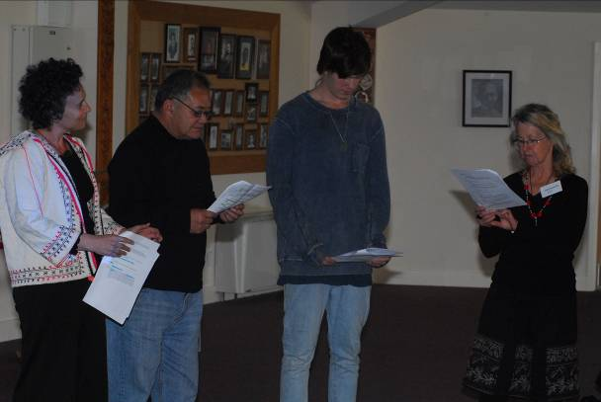
Abstract
This workshop looked at the impact of direct and indirect violence on identity; breaking the cycles of revenge; developing tolerance and moving towards reconciliation. The workshop drew on participant experiences in relation to aggression and experiences of pain, injury and loss, and how these might be dealt with creatively and non-violently. It also explored the place called ‘Reconciliation’ where the values of peace, justice, truth and mercy meet. The presentation very effectively used a short piece of theatre with the characters – truth, justice, mercy and peace to explore the complexities of arriving at reconciliation.
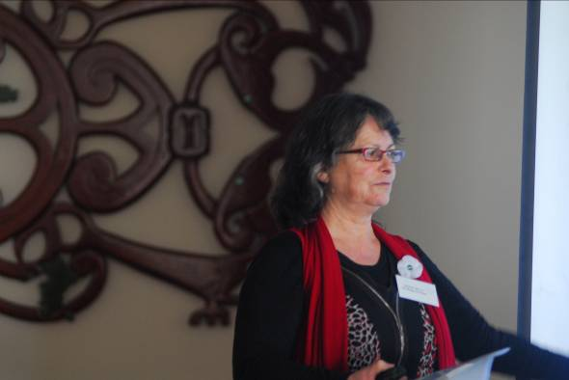
Biographical Notes
Dr Heather Devere is Director of Practice at the Centre. She has experience in dispute resolution and mediation. She has published widely on issues including peace education, women and politics, women in the media, refugee resettlement, children’s rights and the politics of friendship. http://www.otago.ac.nz/ncpacs

- Niue – A Constitutional Model for Rēkohu – Hiva Levi

- Kaitiakitanga Panel

Dr Peter Horsley
Hori Parata
Marion Johnson
Elmer Satala and Dr George (Wolf) Gumerman
Tom Lanauze

- Is New Zealand a peaceful nation? The reality and the rhetoric – Peace Movement Aotearoa (Edwina Hughes)

Abstract
New Zealand is often described as a peaceful nation, but what is the reality behind the rhetoric? There are many social, economic and political realities which challenge that notion, as well as the lack of constitutional protection for human rights - a feature more commonly associated with dictatorships rather than a system of parliamentary democracy. However, the area where the notion of New Zealand as a peaceful nation is most pervasive, and where it is least challenged, is around the ideology of militarism and the outcomes which arise from it.
This workshop explored New Zealand’s role in the global cycle of violence, beginning with an overview of the global situation to set the scene, then focused on the costs and consequences of militarism for our society. The reasons why New Zealand maintains combat ready armed forces were examined, alongside quotes from politicians and senior military personnel about the lack of any direct military threat to the nation.
The workshop included a section on the increasing level of militarisation of children and young persons and their education, based on recent research for reports to the UN Committee on the Rights of the Child, and asked how desirable it is for an institution which has the use of armed force as its primary role to be involved in youth development work.
Militarism and militarisation pose particular challenges for sustainability and respect for life, the planet and the sacred, and an analysis of both is essential for thinking about what sort of changes are necessary to develop the kind of peaceful relationships we want within and among communities here and with communities overseas.
Notes on Peace Movement Aotearoa (PMA)

Peace Movement Aotearoa (PMA) is a national peace organisation based in New Zealand for anyone interested in human rights, peace and social justice. This session will be presented by the PMA Co-ordinator Edwina Hughes. http://www.converge.org.nz/pma/

- Violence Prevention - Mareti Kume and Bronwyn Barnett
Abstract

Volunteers for this workshop participated in creative ways of Peaceful Conflict Resolution. AVP is an experiential workshop where participants practice non violence through activities and communication formulae. Also included are ‘Light and Livelies’ (games) designed to lift the energy from times of profound sharing. We work to develop a sense of community, based on respect for all participants. This is an important basis for developing our own power to find non-violent ways to deal with conflict. We start with affirmation of one-another, go on to work at community and trust building, communication skills, co-operation, and conflict resolution, all of which are essential to a non-violent lifestyle. We expect that the group will find creative alternatives to solving disagreements, problems or conflicts.

Notes on Presenters
Mareti Kume and Bronwyn Barnett presented a workshop based on their experiences with the Alternatives to Violence Project http://avpaotearoa.org.nz/
- Peaceful Conflict Resolution - Samantha Jackson, Otago University

Abstract

Te Houhanga a Rongo Marae in Dargaville symbolises the making of peace between two Te Roroa Rangatira Parore Te Awha and Tiopira Kinaki. Later, the wharenui Rāhiri was built on Te Houhanga a Rongo cementing relationships between Te Aitanga a Hauiti and Ngāti Whātua. Due to the naming of the wharenui, all who descend from the great Northern tupuna Rāhiri are welcome at Te Houhanga. My Master’s thesis looks at the tribal knowledge associated with Ngāti Whātua from a Te Houhanga a Rongo perspective. In particular, I examine how knowledge of whakapapa and expressions of manaakitanga were used as traditional forms of conflict resolution and peace building. I posit that understanding these tribal histories (whakapapa) and tribal knowledge (mātauranga) is fundamental to maintaining relationships and enduring peace between whānau, hapū and iwi from a Māori perspective.
Biographical Notes
Samantha is research assistant to the Dean, School of Māori Studies Otago University. Her Masters thesis explores conflict resolution in a Māori context, specifically Ngāti Whātua.

- Identity Panel
Abstract

  - Stories are the Centre: the primacy of narrative in re-visioning identity - Tina Makereti
In 2009, I began to research a story that had long existed in my family – that one of our ancestors was Moriori. As I gained a clearer understanding of the contentious history of Rēkohu, and the extraordinary culture of Moriori, I wondered why many New Zealanders had such a poor knowledge of this story. Given that so much historical research has been produced by te imi Moriori, The Waitangi Tribunal, Michael King and others, and that we are well on our way to creating rich, accurate and diverse re-visions of the inaccurate histories that were once taught in schools, why is the coloniser’s version of history still so prevalent?
One reason the colonial histories prevail is that they serve the status quo; a possible answer is that we need to change the Stories of our nation. Story has the potency to speak to our hearts and spirits as well as our minds. Story speaks directly to our imaginations. It might be viewed as a tool to both reclaim our histories and identities, and to expand our definitions of self and our potential for the future.

My PhD thesis suggests that fiction may offer readers a more vivid, intimate and visceral relationship with historical events through the creation of fictional characters. The creation of Stories that re-create /re-vision history from different points of view and different time periods may allow for indigenous perspectives to continue to gain new cultural and societal life and replace long held national myths. My thesis also partly consists of a novel. This presentation will explore the process for writing the novel, and include a short reading from the work.

Elmer Satala and Dr George (Wolf) Gumerman – Hopi Nation
Deborah Goomes
Hinemoa Jones

- Peace, human rights and the Treaty – Peace Movement Aotearoa (Edwina Hughes)
Abstract
“If war is the absence of peace, the war has never ended in Taranaki, because that essential prerequisite for peace among peoples, that each should be able to live with dignity on their own lands, is still absent and the protest over land rights continues to be made.” (The Taranaki Report, WAI 143, Waitangi Tribunal, 1996).
This workshop explored the linkages between peace, respect for human rights and the Treaty of Waitangi; and assesses whether the comment in WAI 143 is still relevant fifteen years later as a way of describing the situation throughout Aotearoa New Zealand.
The workshop included an interactive table (that participants assist in completing) which was developed as a way of teaching the interconnections between and among the Treaty, domestic human rights legislation and the main international human rights instruments. Using the foreshore and seabed legislation as an example to demonstrate these connections, the table visually illustrates the lack of protection for the Treaty, and for human rights more generally, from Acts and actions of parliament. Although this example focuses on the individual and collective human rights of Maori and Moriori, the points made apply equally to any legislation or policy affecting the rights of all New Zealanders.
This workshop would be of interest to anyone interested in developing tools for teaching about peace, the Treaty and human rights, or anyone who is interested in discussing how they are connected, what Treaty and human rights protections are in place, why these are ineffective under the current constitutional arrangements, and what we can do about it.

- Ako-a-rongo – holistic learning – Birgit Baader
Abstract
Modern conventional educational systems are set up to support competitiveness and the “survival of the fittest/strongest” in order to prepare young people for the hardships of the harsh reality of the business. Marks, awards, certificates and other ranking systems do not increase solidarity, team spirit, peaceful cooperation. To nurture these and other empathetic qualities within young people we need to provide learning and teaching environments where reciprocal learning is possible and everybody has his/her natural and valued place.
Biographical Notes
Birgit Baader, journalist and author, has been part of a research group of the Ministry of Education in Germany for 8 years exploring “alternative learning concepts” in order to enhance “Schulzufriedenheit” (satisfaction in school for teachers, students, parents) and learning motivation. She has written numerous articles and reports about the free-learning movement in Europe, and about the motifs behind homeschooling and unschooling and other alternative educational options. She is part of Ako-a-rongo, a group promoting peaceful education for all: http://holisticlearning.weebly.com/ and www.birgitbaader.com

- Story-telling as a tool in conflict transformation - David James and Jillian Wychel, Rowan Partnership
Abstract
In this one-hour presentation and discussion, David and Jillian used a number of true stories from our own experience and that of others, and will related them to processes and techniques we have found effective in our practice as mediators and Treaty educators. They considered their value in attending both to the substantive issues and the relationships involved in conflict situations.
Biographical Notes
David James and Jillian Wychel are experienced educators and writers on biculturalism, the Treaty, race relations and spirituality.

APPENDICES
- Te Tohinga Rongo
- Me Rongo 2011 Declaration
- Hirawanu Tapu Peace Scholarship
- Voices of Rēkohu – writing workshop

Te Tohinga Rongo (Renewal of Peace Covenant)
11 November 2011
Kōpinga Marae

The abandonment of warfare and killing is an ancient covenant that has been handed down from the earliest Moriori ancestors to have settled on Rēkohu and Rangihaute. Our karāpuna (ancestors) tell us that the covenant was reaffirmed and passed from one generation to the next.

“It was passed down to Mu and Wheke, and from them and their descendants down to Rongomaiwhenua, and from him to his descendants Nunuku, Tapata and Torea. You may continue to fight; but the meaning of his words was, do not kill.” (1894 transcript)

By forbidding the taking of human life and placing their weapons of war upon the Tūahu (the sacred altar), Moriori entered into a tohinga or covenant with their gods. From that time forward, power over life and death was removed from the hands of man and placed into the hands of their gods. Fighting became ritualised and upon the first blood being drawn fighting was to cease. The leader, Nunuku Whenua reaffirmed the covenant of peace some 600 hundred years ago. Moriori as a people have continued to honour that covenant to this day despite the greatest of provocations.

This covenant was reaffirmed at a large gathering of Moriori at Te Awapatiki in early 1836, to decide what response they would make to the invasion of their Island home in 1835. While the young men urged resistance, the elders, Tapata and Torea insisted that the people hold fast to the teachings of Nunuku. As they said, the covenant was a spiritual pact entered into with their Gods. To break that covenant would represent a betrayal of their Gods and a loss of mana for them as a people. Instead, they offered peace, friendship and sharing of the Island’s resources, as was their custom.

Despite the great suffering and loss that Moriori endured as a consequence of this decision, their legacy of peace and hope lived on. For this generation of Moriori it has become the rallying point for our people. A beacon of light and inspiration that has guided us in reclaiming our culture and identity as a people - our identity as the first peoples of these islands. The covenant has been renewed at other auspicious occasions – the opening of Kōpinga (2005) and the blessing for the World March for Peace and Non-Violence (2009). It is an honour to renew the covenant again today, coinciding with Armistice Day – when the world celebrates an end to fighting and war.

In renewing this ancient covenant of peace we are conscious that peace is as precious and much needed today in the modern world as it was for our ancestors. The challenge left to us by our karāpuna is whether we can learn to live together peacefully and share what we have, respecting each other and the environment that we live in. The alternatives facing this world today do not bear too much contemplation. This ceremony today, while honouring the vision of our ancestors, is also a small but important contribution to the efforts being made by peoples and organisations the world over to make our planet a more peaceful and sustainable place on which to live.

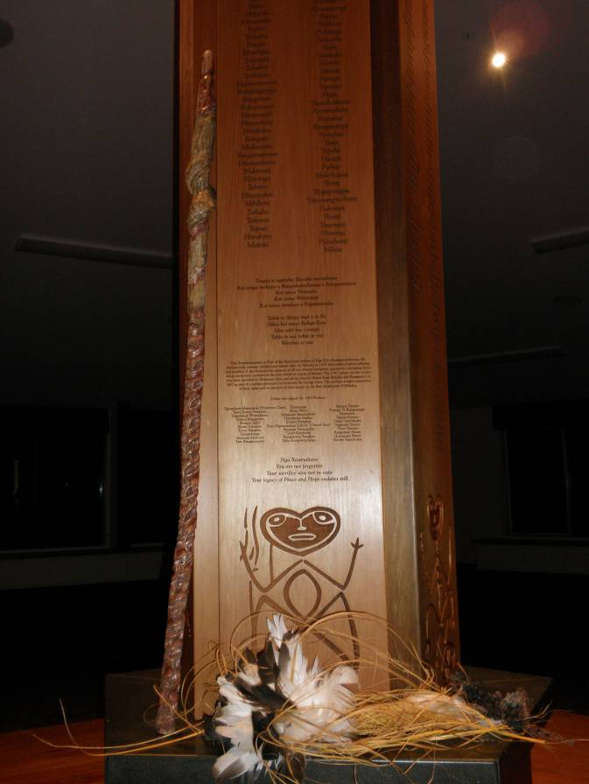
Tradition informs us that the knowledge of the peace covenant was passed from father to son during a tohinga or baptismal ceremony. The old weapons which had been placed on the Tūahu were removed and handed to the child. An explanation was then given to the child that the weapons were once used for fighting and could kill another human being. It was explained that the power over life and death had been taken from the hand of man and placed into the hands of their gods. By replacing the weapon back on the Tūahu, the child was symbolically renewing the covenant for the next generation and completing the tohinga ceremony.

Today Moriori renew our commitment to live together on this Island in peace and to respect and share the resources of the land and the sea. We make this commitment knowing that there are many challenges still to be faced and many lessons still to be learned. But, if we can inspire the next generation to learn about and uphold the values and wisdom left to us by our ancestors, then we will have succeeded in honouring that legacy.

ME RONGO 2011 DECLARATION

PREAMBLE - MORIORI COVENANT OF PEACE

The abandonment of warfare and killing is an ancient covenant that has been handed down from the earliest Moriori ancestors to have settled on Rēkohu and Rangihaute. Our karāpuna (ancestors) tell us that that the covenant was reaffirmed and passed from one generation to the next.
“It was passed down to Mu and Wheke, and from them and their descendants down to Rongomaiwhenua, and from him to his descendants Nunuku, Tapata and Torea. You may continue to fight; but the meaning of his words was, do not kill.” (1894 transcript)
By forbidding the taking of human life and placing their weapons of war upon the Tūahu (the sacred altar), Moriori entered into a tohinga or covenant with their gods. From that time forward, power over life and death was removed from the hands of man and placed into the hands of their gods. Fighting became ritualised and upon the first blood being drawn fighting was to cease. The leader, Nunuku Whenua reaffirmed the covenant of peace some 600 hundred years ago. Moriori as a people have continued to honour that covenant to this day despite the greatest of provocations.
Tradition informs us that the knowledge of the peace covenant was passed from father to son during a ceremony of rites and responsibilities. The old weapons which had been placed on the Tūahu were removed and handed to the child. An explanation was then given to the child that the weapons were once used for fighting and could kill another human being. By replacing the weapon back on the Tūahu, the child was symbolically renewing the covenant for the next generation and completing the tohinga ceremony.

AFFIRMATIONS OF THE COVENANT
This covenant was reaffirmed at a large gathering of Moriori at Te Awapatiki in early 1836, to decide what response they would make to the invasion of their Island home in 1835. While the young men urged resistance, the elders, Tapata and Torea insisted that the people hold fast to the teachings of Nunuku. As they said, the covenant was a spiritual pact entered into with their gods. To break that covenant would represent a betrayal of their gods and a loss of mana for them as a people. Instead, they offered peace, friendship and sharing of the Island’s resources, as was their custom.
Despite the great suffering and loss that Moriori endured as a consequence of this decision, their legacy of peace and hope lived on. For this current generation of Moriori it has become the rallying point for our people. A beacon of light and inspiration that has guided us in reclaiming our culture and identity as a people - our identity as the first peoples of these islands. The covenant has been renewed at subsequent auspicious occasions – the opening of Kōpinga Marae (2005), the blessing for the World March for Peace and Non-Violence (2009) and at the inaugural Me Rongo Congress for Peace, Sustainability and Respect for the Sacred (2011).

ME RONGO CONGRESS

Me Rongo is a Moriori term meaning “in peace”. It is used as both a salutation and affirmation. The word “rongo” also embodies other vital ingredients for peaceful living, as rongo means “to listen”. Me Rongo implies that in order to be in peace, one must also listen, and listen deeply and respectfully. This listening is not just amongst people but also incorporates a deeper listening to the rhythms and sounds of the living systems of which we are a part.
In May 2010, a gathering was convened in Tofino Canada as part of the International Society of Ethnobiology’s 12th International Congress. The Tofino gathering was conceived as a stepping stone in the lead up to the Me Rongo Congress planned for November 2011. The Tofino gathering was held in an indigenous centre and named Hishuk-ish tsa’walk after a Tla-o-qui-aht expression meaning “everything is one”.
The session (entitled “Peace, Sustainability and Respect for the Sacred”) brought together elders and other experts from around the world who have traditions in peace keeping/making as an integral part of their philosophy. It focussed on the importance of the preservation and transmission of inter-generational knowledge of "living in country" as the Aboriginal peoples of Australia say, and the maintenance and promotion of retention of the local language(s) and cultural practices of the communities that sustain this knowledge. At its heart was an understanding of the importance of the sacred/spiritual/wairua traditions – as an expression of the thread that binds people together with their natural worlds, and which provides the basis for living in a mutually respectful and mutually enhancing relationship of humans, plants and animals.

In addition to providing a collective forum for learning about peace traditions and the importance of being able to practice cultural continuity, the session examined ways in which the modern world may come to a better understanding of how this sacred knowledge or knowledge of the sacred is critical to humankind (re)learning how to live "in connection with" rather than increasingly "disconnected from" our planet and planetary systems.

Me Rongo November 2011

The Me Rongo Congress 2011 aimed to reunite people involved in the World March and the Tofino Peace gathering as well as others involved in peace-making or who have peace-making traditions, on Rēkohu in November 7-21, 2011.

At the opening of the Me Rongo 2011 Congress the covenant was renewed and reaffirmed by all delegates. In renewing this ancient covenant of peace we are conscious that peace is as precious and much needed today in the modern world as it was for our ancestors. The challenge left to us by our karāpuna is whether we can learn to live together peacefully and share what we have, respecting each other and the environment that we live in. The alternatives facing this world today do not bear too much contemplation. This ceremony, while honouring the vision of our ancestors, is also a small but important contribution to the efforts being made by peoples and organisations the world over to make our planet a more peaceful and sustainable place in which to live.
On 13 November 2011, the delegates of the inaugural Me Rongo Congress ratified the following Declaration:

ME RONGO DECLARATION

We believe that the creation of a meaningful and lasting, intergenerational practice of mindfulness is essential for establishing a culture of peace and non-violence. When you have hope for future generations, peace prevails.
We are convinced that the Moriori message of peace is something to be proud of and is worthy of sharing with the rest of the world, as an unbroken commitment over countless generations to peacekeeping, and as a beacon of hope. Moriori history on Rēkohu demonstrates that it is possible to consciously and successfully change from a culture that accepted occasional warfare and killing to one of peace and the outlawing of killing.
Our collective experience shows that in order for individuals, communities and states to recover from acts of violence or aggression, a process for meaningful reconciliation needs to occur. The destructive consequences otherwise are intergenerational. Work during Me Rongo highlighted the need to reconcile the sometimes competing values of peace, mercy, justice and truth(s) in order to eventually come to a place of reconciliation.

Our experience also shows that adoption of and adherence to values of peace and non-violence is not simply an option – it is a necessity - in a world of increasingly fragility. This also acknowledges that peace is not simply absence of violence. Peace is contingent on the presence of justice, and the respect for and freedom of identity in our hearts, homes, communities, and across the Earth.

We are further convinced that there is a deep connection amongst notions of peace, ecological resilience, and reverence for human dignity, ritual practices and sacred places: thus the connections at Me Rongo 2011 between “peace, sustainability and respect for the sacred”.

We believe that creative people and cultures in our communities have the capacity to shine a light on truths and the potential for healing through the arts. Artists, poets, writers, musicians and those with the capacity of insight should be valued and respected accordingly. Me Rongo 2011 has recognised this by incorporating the work of artists and their teachings as a protective cloak for this Congress.

We further believe that the year 2011 marks a time of great hope. Global awakenings, and demonstrations of civil societies have shown the hunger for lives of freedom, without fear, want and discrimination – a birthright for all citizens of this planet.

We are aware that this planet is in need of multiple, effective mechanisms for achieving peaceful, non-violent conflict resolution. Conflicts are inevitable in human society, and all cultures strive to evolve nonviolent ways of dealing with them. We affirm the importance of deepening these ways to healing as part of our commitment to non-violence.

This declaration is based on an awareness that the establishment of a culture of peace and non-violence is not an end in itself. Peace is a condition that needs to be constantly worked on. The values stated in this declaration are a step in the larger process of achieving a world without violence.

We, the delegates of Me Rongo 2011:
- Reaffirm our commitment to the Universal Declaration of Human Rights adopted by the General Assembly, 10 December 1948 (which is now honoured as ‘Human Rights Day’) and the legally binding human rights instruments that have arisen from it;
- Reaffirm our commitment to the UN Declaration on the Rights of Indigenous Peoples adopted by the General Assembly, 13 September 2007;
- Reaffirm a commitment to the Charter for a World Without Violence approved by the 7th World Summit of Nobel Peace Laureates in December 2007;
- Endorse the UNESCO Declaration and Programme of action on a Culture of Peace adopted on 13 September 1999;
- Endorse the Vancouver Declaration of 11 February 2011 on Law’s Imperative for the Urgent Achievement of a Nuclear-Weapon-Free World;
- Support the spirit of the draft Code of Crimes against Future Generations prepared by the World Future Council);
- Support those seeking laws and governance to prevent the destruction of our planet by adding the crime of “ecocide” to the existing categories of “crimes against peace” (i.e. genocide, crimes against humanity, war crimes and crimes of aggression).

We, the delegates of Me Rongo 2011 ask the global community of individuals, governments, nation states, educational and scientific communities and collectives such as the United Nations to adopt and endorse the following principles:

- Hokomenetai – unity. Through the gathering together of collective will, knowledge and determination steps towards achieving goals of peace and non-violence will be more easily achieved.

- Sharing. Working as a collective is only successful if participants agree to openly and ethically share their knowledge, energy and experience. Adherence to this principle requires active listening (rongo) to the aspirations, concerns and needs of others.

- Active participation for non-violence. We know that violence begets violence. The increasing normalisation of violence through the media, violent games, and through warfare and terrorism is unacceptable. To end this we need to ensure that individual human dignity is respected, unconditionally. We must also acknowledge that the need to show respect is a requirement of all of us. Changing the passive acceptance of violence is an urgent task and precious gift for future generations

- Pluralism. We live in a plural world where co-existence is an inherent responsibility of life as human beings. Pluralism embraces and energetically engages with diversity in all its expressions and is a powerful force in affirming all cultural and communal quests for peace and understanding. In this sense it moves past ‘tolerance’ to actively seeking understandings across difference(s).

- Peace education. Teaching about peace, non violence and peaceful conflict resolution needs to be promoted for all ages in all levels of our education systems.

- Protecting and valuing natural resources. We recognise that warfare and conflict is often a result of disputes over natural resources or a result of being deprived of adequate natural resources and lands. In order to have a peaceful relationship with our planet we must recognise that humans are part of an interconnected system, and demonstrate respect for all components of our global ecosystem.

- Freedom of identity. We recognise that this freedom is essential for peace to flourish. Individuals, communities and nation states need to be able to practice and use their own languages, cultural practices and traditions. They also need the right to live, safely, on their home lands.

- Protect and respect our sacred spaces and places. These places have the capacity to heal and restore the human spirit, as well as natural processes. In order to care for these places and values we must hold dear and safeguard traditional practices of reverence.
- Protect and respect for Indigenous rights, values and teachings. Most indigenous communities have traditions of deep connection with the Earth and its rhythms and systems. Ensuring that these are valued alongside other knowledge systems is critical for the survival of Earth.

- Nurture and cherish artists, poets, writers, musicians, spiritual leaders and visionaries. These people are treasures in our communities and through their skills have the capacity to reveal truths and deeper understandings. They also have the potential to enable healing as well as link people together through common interests, aspirations and enjoyment.

- Promote research and dialogue on conflict resolution. The promotion of research and deep discussion on peace and conflict resolution should be supported financially and philosophically so as to enhance its place in our academic and vocational arenas. Our poets, philosophers, teachers, wise elders and artists in general should be encouraged to join us in this endeavour.

Glossary of Moriori Terms Used in the Declaration
Moriori word | English meaning
Hokomenetai | To gather together in unity
Karāpuna | Ancestors
Kōpinga marae | Kōpinga means a grove of kōpi trees. These were traditional places where the Moriori gathered to debate, celebrate and commemorate events. Kōpi is native to the island but is a tropical tree brought with the first Polynesian settlers to the island (Corynocarpus spp)  A marae is a traditional, communal gathering place
Mana | Integrity and honour
Rangihaute | Moriori name for the smaller of the two main islands of the Chathams, also known as Pitt Island
Rēkohu | Moriori name for the Chatham Islands – their indigenous home lands
Rongo (Me Rongo) | Rongo means peace as well as ‘to listen’. Me Rongo (in peace) is also a salutation, suitable for all occasions
Te Awapatiki | Literally ‘the path of the flounder’. This is the location of the outlet to Te Whānga Lagoon on Rēkohu and where the elders met to lay down the covenant of peace and then, in 1836, to debate whether to uphold it still
Tohinga | Covenant and also a baptism or dedication rite
Tūahu | Altar, sacred place for ritual practices

- HIRAWANU TAPU PEACE SCHOLARSHIP
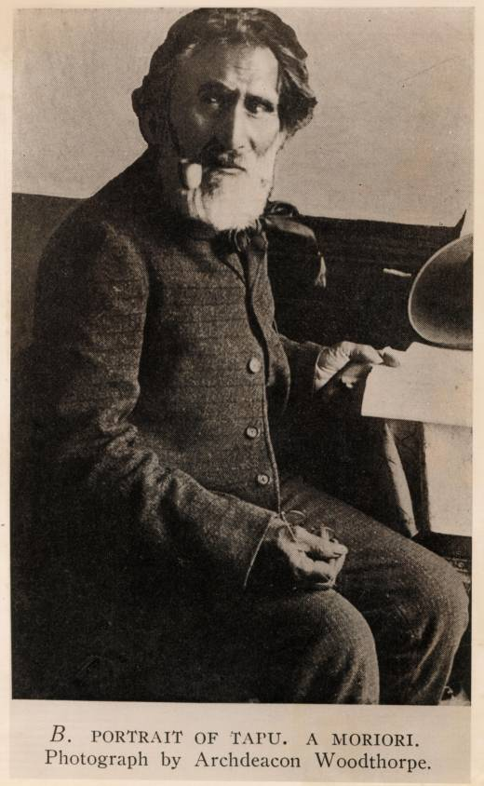
At the inaugural Me Rongo Peace Congress held in November 2011, Hokotehi Moriori Trust announced an inaugural Peace Scholarship to be named in honour of Hirawanu Tapu, a Moriori leader and scribe who worked closely with Alexander Shand to record and preserve for posterity Moriori traditions and history. It was Tapu who also wrote a petition to Sir George Grey in 1862, signed by all the Moriori elders alive at that time, seeking restoration of their lands and other rights on Rēkohu. He was a well educated man who spoke several languages and was the last full speaker of the Moriori re (language) when he died in 1898.
The Peace Scholarship is to honour the 600 year peace keeping tradition of the Moriori people and to honour the legacy of peace bequeathed by Moriori ancestors to modern day descendants.
The scholarship is for an annual amount of NZD $10,000 and will be awarded in the first instance to any person of Moriori descent studying in a relevant field of study related to indigenous peace studies and conflict resolution at a tertiary level in New Zealand or overseas. If there is not a person of Moriori descent in any year who would qualify, the scholarship may be awarded to someone who is not of Moriori descent but who otherwise meets the criteria for the scholarship. The objective is to increase the understanding and research scholarship associated with Moriori, Maori and other indigenous peace-making and peace keeping traditions in New Zealand and elsewhere. Hokotehi trustees will have discretion in any year not to award the scholarship if there are not suitable applicants.
The scholarship is also to support the work of the National Centre for Peace and Conflict Studies established at Otago University. Hokotehi Moriori Trust, in association with the Aotearoa New Zealand Peace and Conflicts Studies Trust, was instrumental in setting the Centre up between 2005-2009.
- Voices of Rēkohu Writing Workshop

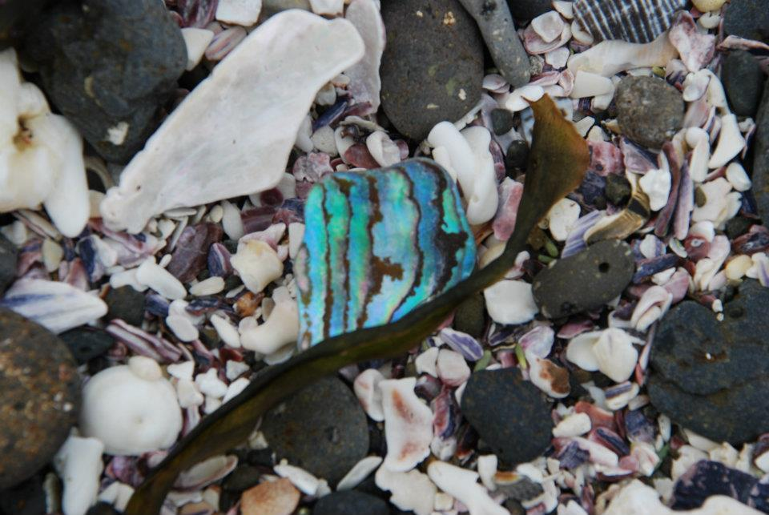

Writing Workshop
Me Rongo Peace Festival
November 2011

LOUISE NIELSEN

Age 7 ½

I was crying
I like to play
I remember hugging my brother one day
I remember kicking my toy.

I saw the water moving
There was music playing it was loud.
There was volcanic cones.
We zoomed past the fern
The fern was by the road
We saw calf and cow.

I see my friends every day at school when we are reading and working and running.

I remember reading my book. My book was about Mitch to the Rescue and the Careful Crocodile.

I imagine the crocodile jaws go snap and her hiding under the ferns to keep her eggs safe.

JAHVANTAE PIRIKA

Age 6

I see the sky. The sky is blue and white and I see the sun is very bright. It makes hot. We can play when the sun is shining. When the sun is shining it makes me happy. When the sun is shining the birds are singing.

I imagine flying around the world to find out more about birds. There are so many different birds. I am interested to find out about them.

The seaweed is dancing around the rock pool.
It is dancing by itself.
It is a slow dance.

P.J. PIRIKA

Age 10

I see the fish jumping out of the water like birds flying high through the trees. I see the dolphins going under the water like whales swimming through the sea. I see the birds flying through the clouds like fish swimming between the rocks.

I remember when we got our beehives. We put them behind the school in the sun. The first time we went to the hives to check them they were doing great and they have lots of food. A few days later they were dying and later we found the queen was dead so we got some more hives. And they are thrilling.

I imagine being an All Black running across the field so fast that I can fly through the sky. I imagine being a megalodon eating all the fish. I imagine being a monkey swinging tree from tree and eating banana’s all day.

The sea waves are chasing each other back and forward making the seaweed dance. The sea is like looking through glass seeing its reflection. The sea is flowing through the rock pool making the fish come out.

NICOLE WHAITIRI

Age 12

As the last of my memories fade with a quick glimpse back in time I recall a special memory of a woman full of love cradling me in her arms. As my past experiences fade away only to be relived time and time again.

When I was playing at the Norman Kirk Hall, all I could see were old and new cars and trucks driving past. I could see the rust of the old and the shine of the new vehicles.
As I sat and watched a man training his racehorse I couldn’t help but to notice the horse’s shiny coat and polished hooves. The horse’s running movement held me mesmerised.
I recalled watching the horses running, galloping, and jumping through an opened paddock and enjoying the breeze blowing through the manes.
I imagine all the birds gliding in the cold, windy breeze and their wings flapping hard to get out of the cold and into the warmth.

SERENA WHAITIRI

Age 10 ¾

As I felt my fontanelle close I realised that all the knowledge and experiences that I brought into this world with me will now be forgotten until certain moments in time when I experience them again.

I see the wind whistling through the trees as I travel home. I notice the fern is slowly crawling to the ocean with the waves reaching up to take the fern in their arms and the birds slowly making their way to their destinations.
I remember looking back to see the shining sun smiling at me while I travel home past the beach. I remember the chill that shivers down my spine, a feeling I have felt so many times before.
I remember the wind pushing me along as I run past all the houses that are slowly fading away.
I imagine that when I look upon the ocean I see dolphins and whales jumping out of the sea water, flipping and twisting into the air, hoping their friends will come and join them.

TE NGAERE ANNIE BOTTCHER

I see the beauty of my father’s face (looking with so much love and care at my little mother)

I remember his concern for her and his instant love for me.

I imagine my son looking at his woman and first daughter the same way – and it happened – and I knew I had been an okay mother (job well done? I hoped).

Paradise Regained

Sky, sea and on this ground
Beauty of nature all around
Harmony feast from ancient eyes
‘Keep it safe’ my open heart cries
Nurturing all the mokopuna well
In paradise they will always dwell.

SUSAN CARTER

My tipuna are gathered around.
They know the signs that
soon my time of past memories
will come to an end.
There is a reluctance to let
me go.
They are fearful of the battering
and bruising that is to come.

SYLVIA EYLES

Get back to the cottage from the writing workshop – weka shit! And not just the fresh one on the mat that spells WELCOME, which I stand in, in my sock – but, four other splots, dried white by the sun.
Next I notice a maidenhair fern lying on the deck, its pot upturned, the soil scattered. And there’s the *?!! cat snoozing on my chair. She would have calmly laid there, turning a deaf ear and a blind eye to their dirty, destructive activities. Or maybe she was too rigid with fear to move. No, she is just too old and lazy, only chasing them when the mood suits.
The maidenhair fern came from the family home in Blenheim. A large patch grew outside my mother’s bedroom (my old room). When she died twenty years ago, I took many cuttings from the garden back to Kaka Point. Today, all I have is the fern. Oh, and the rhubarb. I was sad when the blackcurrant didn’t survive the trip to Rēkohu. Would be more useful than an ornamental fern and less of a reminder of mother. I disliked my mother, thinking of her gives me a pit in my stomach, so I switch my thoughts back to the wekas.
Having been a chef/cook in a past life I imagine writing a recipe book – ‘Ways with Wekas’. I see myself sitting here on the deck, using my slingshot with deadly accuracy to secure the main ingredient, and have my revenge.

Wekas 2009 Kōpinga

Tom caught them
Susan plucked them
I cooked them and
We all enjoyed them.

HINEMOA JONES

Karengo sweeper of the sea
Wraps her slimy arms over
Her rock-a-bye babies
Dabbing the corners of their mouths
Like a mama with a spit-filled hanky
Mirroring the moana moves
Reminding Tangaroa he is not alone
Karengo moves with him
A follower & a leader depending
On which way the water flows

In the beginning there was nothing.
Then I found the darkness
Layers and multitudes of night
All shades of deepest dark
I rolled and explored the dark black
I breathed in the silent dense unknown
I waited
After some time and space I was born
IT WAS BRIGHT
I understand this light is life
I forget where nothing lives
And look forward only to everything.

I see sea
I wanna be sea
But it’s too fresh for me
Gee
When did this happen to me
Afraid to feel free.

I remember once upon a time
Like sweet creamy oysters
This big whole world was mine
Divine, sublime
Political disgust, wonder lust
Bring it on, just give me a sign
I’ll do anything, I don’t care
I’ll be FINE

I imagine if this is the way I stay
In the end it’ll be the fear that takes me away
Scared of myself
Afraid night and day
So better go for a swim, seize the day!
Before this creeping fear makes me gray.

MARETI KUME

Who was I?

I remember feeling safe
I am confident
I am acceptable
I have free will
I am of spirit
And then… I heard myself cry.

The pool of water runs through my
veins like singing electricity
making my skin dance
to the pumping of my blood.

Motivated by this homework and for the first time since arriving on Monday, I go for a walk.
I saw colours upon colours and then with one stroke I saw the canvas they lay on. I left Liz’s creative painting workshop feeling connected to her which was totally different to the stranger I remember six years ago. I imagined us as great friends.
In front of me I see a fence line of harakeke and a horizon of water and remember a feeling of intrusiveness so I stop myself from going that way but still imagine the far off look on my face with the wind blowing through my hair.
I walk between two big sheds and see an open door hoping the sounds of koauau I hear are coming from inside there.
I remember to John my limitations of raranga being a flower with petals that fall out when dried looking more like a spring than a flower. I imagined I could learn from John. A smile as I left through the opened door.
Upon opening the door to the last shed, I see to my left five busy figures, in front of me one large figure and to my right two more busy figures of which one is just a boy.
I remember trying to look invisible but comfortable, trying not to be intrusive but said hello to be polite. I tried to help myself by imagining myself a great observer and realised what I had been observing was myself.

LEE MEAD
yesterday, today, tomorrow

I see
friendly beautiful people
quiet intimate discussion
tamariki pure amongst
the landscape
emotional
windswept
vast but with end.

I remember
looking out the window
the wind swirling through acres of long grass
the wake of an invisible entity
taniwha
searching for me
scared
hiding
the bedroom door opening
mum or dad I don’t know
it doesn’t matter I am safe.

I imagine
my children, and their descendants
upon the land, not much different
ideals and problems
an unknown future era
evolution advance.

Rebirth
dark and cold
that which was once, is no more
guttural sadness
healed by wonder
of coloured smoke and prismical light
the journey long, destination now close
happiness within
a new chance to begin
warm and light.

http://www.tbgf.org/ice/home
http://www.theworldmarch.org/
http://www.moananz.com/
See Appendices
http://www.tbgf.org/ice/home
http://www.otago.ac.nz/ncpacs

